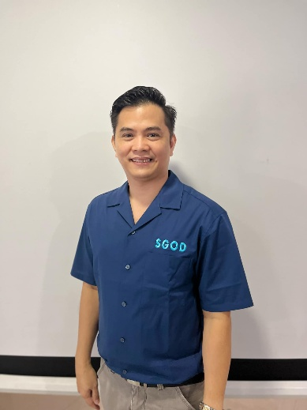

School Governance & Operations Division (SGOD)
TECHNICAL ASSISTANCE FEEDBACK RESULTS (JULY)
Name: Jonathan P. Domingo Designation: SGOD Chief
No. of Schools: 18 No. of Customers: 20
Rating: 4.000 Descriptive Value: Very Satisfactory

Jan | Feb | Mar | Apr | May | Jun | Jul | Aug | Sep | Oct | Nov | Dec
4.000 | 3.992 | 4.000 | 4.000 | 3.986 | 4.000 | 4.000
Monthly TA Feedback Results

Number of Customers Served
Jan | Feb | Mar | Apr | May | Jun | Jul | Aug | Sep | Oct | Nov | Dec
4 | 48 | 17 | 1 | 86 | 12 | 20

Comments and Suggestions
- "Thanks for the timely T.A provided"
- Thank you
- The Technical Assistance provided by the SGOD Chief was highly informative and responsive to my queries regarding my application for promotion. The discussion clarified the prescribed guidelines, documentary requirements, and evaluation process, enabling me to better understand the promotion system. The guidance and practical recommendations shared helped address my concerns and increased my confidence in preparing complete and accurate application documents. I sincerely appreciate the time, expertise, and support extended during the technical assistance even without appointment, maraming salamat po Dr. Domingo!
- The orientation was a reminder that we should be be aware of what it has to be a safe school for learner, teachers and all personnel.
- Congratulations po!!!
- Thanks for the TA
- Thank u po sa timely TA
- I really appreciate the patience of Doc Jho in guiding me through the process really helped me feel more confident. I also admire the professional approach during the TA.
- The topic was explained clearly.
- TA provider helps much for betterment of school’s planning, improving and development.. Thank you so much ❤️
- With Dr. Domingo, all my queries and doubts are answered and clarified. He is an excellent TA provider. Thank you so much sir!
- Thank you chief for giving us the overview of this order
- Thank you for the TA sir jo
- Thank you po sir
- "well explained"
- Thank you so much.
- Thank you very much po, Sir.
- Thank you
- Thankful for this orientation. Napapanahon na usapin. At sobrang salamat po sa pag share ng ginamit ppt. big help po sa San Luis Fam.
- Thank you for this session. We just hope to have recorded copy of the session as well as slides presentation, if possible. And I am sorry that as much as I would love to listen, we also have equally important things to attend to at the school and so we miss important points of the session. We acknowledge and appreciate the video recording if f2f seminar is not applicable. Sorry again for this request and thank you in advance 🙏

 | Schools Provided with TA
1 | Antipolo National Science and Technology HS
2 | Apia Integrated School
3 | Bagong Nayon I ES
4 | Bagong Nayon II NHS
5 | Canumay ES
6 | Cupang ES Annex
7 | Dalig NHS
8 | Dela Paz ES
9 | Dela Paz NHS
10 | Inuman ES
11 | Mambugan I ES
12 | Mambugan II ES
13 | Mayamot ES
14 | Mayamot NHS
15 | Nazarene Ville ES
16 | Paglitaw ES
17 | San Luis ES
18 | San Roque NHS


Prepared by:

DR. JONATHAN P. DOMINGO
SGOD Chief

